

E-BOOK

Golden Visa

Residence Permit | Citizenship by Investment

18th Edition – Portugal
January 2019

By: PTGoldenVisa
Contact Person: Sara Andrade

Tel. Whatsapp/ Viber / WeChat +351 962 284 098

Email: contact@ptgoldenvisa.com / info@ptgoldenvisa.com
Skype: PTgoldenvisa

E-Book – PTGoldenVisa - Index

I Introduction 3

II Investor Visa Program Simple Overview 4

III How to obtain Investor Visa (Residence and Passport) 6

IV Renewal of Residence Permit 16

V Family Reunification and Residency Permit 16

VI Our Office Services 18

VII First Steps to Initiate Investor Visa Application Procedure 21

VIII Example of Full Investment Costs for a Family of 3 persons 23

IX Contacts 27

This E-Book is directed to Investors who for any reason would like to obtain Residence permit in Portugal and consequently in Europe (Schengen space), Investors who would like to obtain Portuguese citizenship or Investors that would like to take the advantage of their current Portuguese investments and collect all the benefits by submitting the Residence Permit application. This is suitable for people who want to collect the benefits without having to live in Europe or families who intend to relocate now or in the future.

I. Introduction

Welcome and thank you for choosing our company. We are thrilled to be at your service and happy to assist you anytime.

PTGoldenVisa founders started their operation by the end of 2012, right the same instance as the program was launched (October 2012). Since then the Portuguese government has granted over 6962 Investor Visas, which constitutes an investment amounted to over 4.2 billion Euro. Whereas 94% of these investments were done through real estate acquisitions, the option of capital transfer was chosen by 5% of the applicants and 1% of applicants have chosen the remaining investment possibilities. However the predictions for next year, considering the new possibility to qualify under the option of investment funds will represent at least 10%.

About us
a. Who are we
PTGoldenVisa offers full integrated services with a specialized team for Investor Visa application procedures, helping investors choose their optimal investment options and proceeding with the application for the Residence Permit and eventually Citizenship. We also provide our clients with the Property Management service in order for them to generate income from their investments.

Our team includes Investment Consultants, Economists, Real Estate Legal Advisers, Architects, Realtors and Lawyers fully specialized in immigration law who will be ready to guide you through the aspects of Portuguese Economy and Real Estate Investments. With over 10 years of experience in Investment, Property Management and Law business, we are fully dedicated in finding service solutions for our clients who we have been supporting from the very beginning of the Investor Visa Program. Our success rate so far is 100% for all the investor applications (General Government approval rate is 97%).

Our Main Qualities:

- Skilled team capable to solve all issues related to the Investor Visa

- Proactive solutions reducing your risks to almost zero

- We will empower your Assets into High Profitable Solutions

- Excellence in Legal Advice and Resolution of different kinds of situations

- Vast experience in the Immigration Law

II. Investor Visa Program Simple Overview

With new legal opportunities to apply for the Residence Permit in Portugal (Europe – Schengen Area) pursuing investment activities you are getting a chance to freely travel in Europe and work and study in Portugal. This will enable you to settle down in any of the European countries (Schengen Area) once you get the citizenship. Getting a Portuguese Investor Visa is not only obtaining a Residence Permit Card but it is also the opportunity to become a Portuguese Citizen (European Union Citizen).

In order to obtain Residence Permit Visa (Investor Visa) you need to meet the following investment requirements:

An Investor Visa is granted only to foreign individuals (non-EU citizens) who fulfill the following requirements for a minimum period of 5 years:

a) Purchase Real Estate in total value equal or greater than:
- 500.000 Euro (half a million Euro) with no restrictions;
- 400.000 Euro (four hundred thousand Euro) for properties located in low density areas - less than 100 habitants per km2;
- 350.000 Euro (three hundred and fifty thousand Euro) for old proprieties built over 30 years ago with renovations work involved;
- 280.000 Euro (two hundred and eighty thousand Euro) for old properties built over 30 years ago with renovations work involved, in low density areas - less than 100 habitants per km2.

Whatever your choice shall be, you are fully entitled to buy one or more property regardless of the type (residential, commercial and etc.) property. You are free to choose from Residential, Commercial, Rural or Plots properties. The investment amount is a net amount. Additionally, you will need to consider the Property taxes on top of this value (maximum level for transfer tax on residential properties is 6% and Stamp Tax is 0.8%, for Commercial Properties the transfer tax is 6.5% and Stamp Tax 0.8%). You are free to live in or rent out your property, it can always be a source of your income.

b) Capital transfer with a value equal to or above 350.000 Euro (three hundred and fifty thousand Euro) for purchasing shares in venture capital fund or investment fund generated to capitalize Portuguese companies where the investment value in Portuguese assets needs to be at least 60%.

c) Transfer capital of the amount equal or greater than 1.000.000 Euro (1 million) into a Portuguese Financial Institution for a period of 5 years. The certification of this transfer needs to be provided by a Financial Institution in order to be able to apply for the Investor Visa.

d) Investing 350.000 Euro (three hundred and fifty thousand Euro) in Share Capital of a company that maintains or creates new 5 permanent for minimum period of 3 years. All these jobs need to be permanent and certified by local Social Security Institution.

e) Capital transfer with a value equal to or above 350.000 Euro (three hundred and fifty thousand Euro) for investing in research activities conducted by public or private scientific research institutions involved in the national scientific or technologic system.

f) Capital donation with a value equal to or above 280.000 Euro (two hundred and fifty thousand Euro) for artistic output or an organization supporting the arts, for reconstruction or refurbishment of the national heritage through the local and central authorities, public institutions, public corporate sector, public foundations, private foundations of public interest, networked local authorities, local corporate sector organizations, local associations and public cultural associations pursuing activities of artistic output and reconstruction or maintenance of the national heritage.

This investment can be made in the name of a company as long as you are the sole shareholder of the Portuguese company.

Once you obtain your Residence Permit you are entitled to freely travel, live or work in Schengen Area that is composed of 26 countries and enjoy the same visa policy. (Austria, Belgium, Czech Republic Denmark, Estonia, Finland, France, Germany, Greece, Hungary, Iceland, Italy, Latvia, Lichtenstein, Lithuania, Luxembourg, Malta, Netherlands, Norway, Poland, Portugal, Slovakia, Slovenia, Spain, Sweden and Switzerland)



- How to Obtain Investor Visa and European Passport (Portugal)

With new legal opportunities to apply for the Residence Permit in Portugal (Europe – Schengen Area) pursuing investment activities you are getting a chance to freely travel in Europe and work and study in Portugal. This will enable you to settle down in any of the European countries (Schengen Area) once you get the citizenship. Getting a Portuguese Investor Visa is not only obtaining a Residence Permit Card but it is also the opportunity to become a Portuguese Citizen (European Union Citizen).

An Investor Visa (Residence Permit) is only granted for foreign individuals; non EU citizens that are able to invest for a minimum period of 5 years.

Once you obtain your Residence Permit you are entitled to freely travel, live or work in Schengen Area that is composed of 26 countries and enjoy the same visa policy. (Austria, Belgium, Czech Republic Denmark, Estonia, Finland, France, Germany, Greece, Hungary, Iceland, Italy, Latvia, Lichtenstein, Lithuania, Luxembourg, Malta, Netherlands, Norway, Poland, Portugal, Slovakia, Slovenia, Spain, Sweden and Switzerland)
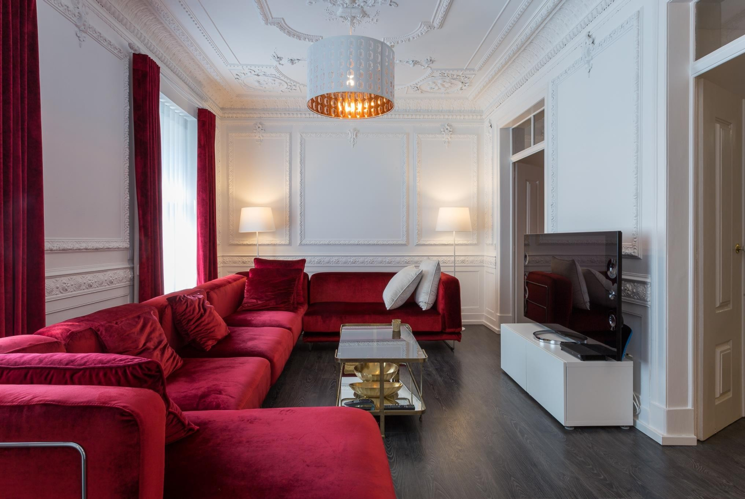

III. How to Obtain Investor Visa and European Passport (Portugal)

Before you initiate the application process for the Residence Permit you are required to fully complete your investment option. Only having done so, will you be able to request your Golden Visa - Residence permit Card.

To request the Residence Permit, we will need to submit your application to Portuguese Immigration Service (SEF). Only upon completion of your investment, you will be requested to submit your Biometric data to the Immigration Department (SEF) in Portugal.

Please, find below the required list of application forms and legal documents:

- A complete copy of the passport (all pages) (Please send it to us at info@ptgoldenvisa.com);

- Police Clearance Certificate from the Residence Country issued within last 3 months, duly legalized by apostille certification or by the corresponding Portuguese Embassy from issuing country, if no apostille is available;

- Sworn statement by the Investor attesting that he will comply with the minimum amount and time requirements regarding the investment activity in Portugal (We will provide you with this form);

- Declaration issued by the Portuguese Tax Authorities and social security attesting the inexistence of any debts of the foreign national to the said entities (we will obtain this declaration in your name);

- Proof of one of the investment types mentioned above (We will obtain this for you once you have completed your investment).

It’s mandatory that all the foreign documents are officially translated to Portuguese and legalized with apostille certification. (If your country has not signed Apostille Hague convention, the legalization of the documents needs to be done to the documents translated into Portuguese or English and presented at the Portuguese Consulate or Embassy corresponding to the country of origin of the documents).

Once the request has been made at the Portuguese immigration authorities (SEF) with all the necessary documentation, the application request shall be reviewed within 90 days.

Usual time for Resident Permit Cards approval is 12 weeks after submission and around 3 to 4 for them to be issued and available to be collected.

Apostille Certification

Please, find below the countries that have recognized apostille legalization. If the country issuing your documents is not on the list below you will need to request a Portugal Embassy to certify/legalize your documents:

Albania, Andorra, Argentina, Armenia, Azerbaijan, Australia, Austria, Belarus, Belgium, Bosnia and Herzegovina, Belize, Bulgaria, Burkina Faso, Canada, Chile, China, Costa Rica, Croatia, Cyprus, Czech Republic, Denmark, Ecuador, Estonia, Egypt, Finland, France, Georgia, Germany, Greece, Hungary, Iceland, India, Ireland, Israel, Italy, Japan, Jordan, Kazakhstan, Korea (South), Latvia, Lithuania, Luxembourg, Liechtenstein, Malaysia, Macedonia, Malta, Mauritius, Mexico, Monaco, Moldova, Montenegro, Morocco, Netherlands, New Zealand, Norway, Panama, Paraguay, Peru, Philippines, Poland, Portugal, Romania, Russian Federation, Saudi Arabia, Serbia, Singapore, Slovakia, Slovenia, South Africa, Spain, Sri Lanka, Suriname, Sweden, Switzerland, Tunisia, Turkey, Ukraine, United Kingdom, Ireland, Uruguay, USA, Venezuela, Vietnam and Zambia.

Embassies where you can confirm Stamp the Documents if no Apostille Certification is available

AFEGANISTAN | Embassy of Portugal in Ankara
ANGOLA | General Consulate of Portugal in Luanda
BANGLADESH | Embassy of Portugal in New Delhi
BENIN | Embassy of Portugal in Abuja
BOLIVIA | Embassy of Portugal in Lima
BOTSWANA | General Consulate of Portugal in Johannesburg
BRAZIL | Embassy of Portugal in Brasília/ General Consulate in Rio de Janeiro/ General Consulate of Portugal in Sao Paulo/ General Consulate of Portugal in S. Salvador da Baía/ General Consulate of Portugal in Belo Horizonte
BURKINA FASO | Embassy of Portugal in Dakar
BURMA/MIANMAR | Embassy of Portugal in Bangkok
BUTAN | Embassy of Portugal in New Delhi
CAMAROON | Embassy of Portugal in Abuja
CAMBODJA | Embassy of Portugal in Bangkok
CANADA | Embassy of Portugal of Portugal in Otava/ General Consulate of Portugal in Montreal/ General Consulate of Portugal in Toronto/ General Consulate of Portugal in Vancouver
CENTRAL AFRICAN REPUBLIC | Embassy of Portugal in Kinshasa
CHAD | Embassy of Portugal in Abuja
CHILE | Embassy of Portugal in Santiago
CHINA | Embassy of Portugal in Beijing
COMORES | General Consulate of Portugal in Maputo
CONGO BRAZAVILLE | Embassy of Portugal in Kinshasa
CUBA | Embassy of Portugal in Havana
DEMOCRATIC REPUBLIC OF CONGO | Embassy of Portugal in Kinshasa
DJIBOUTI | Contact vistos@dgaccp.pt
EAST TIMOR | Embassy of Portugal in Dili
EQUATORIAL GUINEA | Embassy of Portugal in São Tomé
ERITREA | General Consulate of Portugal in Maputo
ETHIOPIA | Embassy of Portugal in Sao Tome
GABON | Embassy of Portugal in Dakar
GAMBIA | Embassy of Portugal in Abuja
GANA | Embassy of Portugal in Mexico City
GUATEMALA | Embassy of Portugal in Dakar
GUINEA | Embassy of Portugal in Bissau
GUINEA BISSAU | Embassy of Portugal in Bissau
GUYANA | Embassy of Portugal in Havana
HAITI | Consulate of Portugal in Port-au-Prince
INDONESIA | Embassy of Portugal in Jakarta
IRAK | Consulate of Portugal in Arbil

IRAN | Embassy of Portugal in Tehran
IVORY COAST | General Consulate of Portugal in New York
JAMAICA | Consulate of Portugal in Kingston
JORDAN | Consulate of Portugal in Amman
KENYA | Embassy of Portugal in Nairobi
KIRGUISTÁN | Embassy of Portugal in Moscow
KIRIBATI | Contact vistos@dgaccp.pt
KUWEIT | Embassy of Portugal in Kuwait City
LAOS | Embassy of Portugal in Bangkok
LEBANON | Embassy of Portugal in Nicosia
MADAGASCAR | Embassy of Portugal in Pretoria
MALAWI | Embassy of Portugal in Harare
MALAYSIA | Embassy of Portugal in Bangkok
MALDIVES | Embassy of Portugal in New Delhi
MALI | Embassy of Portugal São Tomé

TANZANIA THAILAND TOGO
TURKEMENISTAN UGANDA
UNITED ARAB EMIRATES UZBEKISTAN
VIETNAM YEMEN ZAMBIA ZIMBABWÉ
General Consulate of Portugal in Maputo
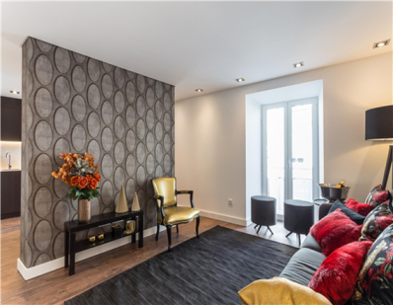

Embassy of Portugal in Bangkok
Embassy of Portugal in Abuja
Embassy of Portugal in Ankara

General Consulate of Portugal in Kinshasa
Embassy of Portugal in Riyadh or Abu Dhabi
Embassy of Portugal in Moscow
Embassy of Portugal in Bangkok Embassy of France in Muscat
Embassy of Portugal in Harare
Embassy of Portugal in Harare

Main Requirements

The Investor must take into account the following general requirements regarding the investment and the required minimum stay period in the country:

I) A five-year minimum investment time is required counting from the date of the residence permit approval;

II) Minimum period of stay in Portugal is 7 days in the first year and 14 days in the subsequent 2 years;

The minimum stay requirement can be fulfilled with several trips or with just one (there is no restriction).

III) The initial permit is valid for 1 year, and is renewable subsequently for a period of 2 years providing the requirements mentioned above are met.

A) The Real Estate Investment Option

In order to obtain the residence permit through the acquisition of real estate assets, the following documents must be presented:

I) The Purchase and Sale Public Deed or the Promissory Purchase and Sale Agreement which shall include a declaration issued by a financial institution certifying the effective transfer of capital for the purchase or for payment of the deposit in the amount equal to or greater than minimum investment requirement (we will conduct the deed for you and collect the declaration from the Bank);

II) Up-to-date land registry certificate attesting the name of the investor as the owner of the real estate (we will collect this certificate for you);

III) Purchase the property in co-ownership, provided each co-owner invests the amount equal or greater than minimum investment required for the selected option;

IV) Promissory Sale and Purchase Agreement that requires the down payment of an amount equal or greater than minimum investment requirement. In case of the Promissory Purchase and Sale Agreement with the down payment of minimum required investment, the actual purchase of the real estate must be completed before the first renewal of the residence permit;

Please note, that the law refers to properties (in plural) or real estate assets in the amount equal or greater than minimum investment required, which means the investor may, for example, purchase two properties each in half of the amount of the minimum investment required;

VI) The property purchased may be leased or subjected for commercial, agricultural or touristic use.

Tax Implications

When buying a property in Portugal the investor is responsible for paying the following taxes:

- Transfer Tax (IMT) — this is a property purchase tax that must be paid before finalizing the deed.
Upon its payment, a proof of payment is issued by the Local Tax Office. The tax due for payment depends on the price of the property and is calculated based on its market price OR its value estimation, registered in the tax department documents (WHICHEVER HIGHER).

A1. Tax Implications

When buying a property in Portugal the investor has to pay the following taxes:

1. Transfer Tax (IMT) — this is a property purchase tax that must be paid before the final deed. As the payment takes place, a document is issued by the Local tax office, which proves its payment. The tax to be paid depends on the price of purchase of the property or, if higher, on the value that is registered on the property tax document;

Property Transfer Tax Table

Property Value  Up to €92.407 | Transfer Tax  1% | Rebate Value  0
From €92.407 to €126.403 | 2% | €924,07
Up to €126.403 to €172.348 | 5% | €4.716,16
Up to €172.348 to €287.213 | 7% | €8.163,12
Up to €287.213 to €550.836 | 8% | €11.035,25
Up to €550.836 | 6% | 0

2. For Residential real estate — the regression table applies, and a maximum of 6% is applied to the values exceeding €550 836; (Calculation for a €500.000 property: €500.000 x 8% - €11.035,25 = €28.964,75)

3. Commercial property or Touristic Properties or a land for construction — 6,5%;

4. Rustic property (without building permission) will be charged at a flat rate of 5%;

5. Stamp Tax — upon signing of the deed. The purchaser must pay the stamp duty that varies according to the type of deed or operation. For real estate property, a sale and purchase is assessed at 0.8%;

6. Annual Tax (IMI) — an annual tax to be paid by the property owner calculated based off the official evaluation of the property for tax purposes. The rate varies between 0,3% and 0,5% for urban properties (the actual tax rate is fixed annually by the respective municipality) and 0,8% for rural properties;

(Since the actual tax is based on an estimated property value that is much lower than the market price, we usually estimate it as 0.2% of property purchase price).

7. Notary and Registration fees — the buyer is fully responsible for paying notary and registration fees once the final deed is signed. Please expect to pay around €750 per property acquisition.

B) Investment fund

By investing the minimum of 350.000 Euro, the investor is immediately qualified for a Residence Permit in Portugal and after 5 years is able to apply for Citizenship. The investment will focus in acquiring positions of control in Portuguese Real Estate companies through direct asset acquisitions with focus in developing high-quality assets with high demand sales and rental income.

C) The investment option of One Million Euro transfer

Following this option, the investor opens a Portuguese bank account in which a transfer in the amount of one million Euros is made. Please note, that applications made with several bank accounts are not accepted. The expected return on fix deposit interest is currently less than 0.1% a year.

This interest is subject to taxation with the rate of 28% by the Portuguese Government, only applicable for tax residents in Portugal.

D) Other investment options - for more information about other available options, please contact us.

IV. Renewal of the Residence Permit – Investor Visa

The residence permit is valid for a period of 1 (one) year from the date of its issuance and can be renewed subsequently for period of 2 (two) years provided that the initial conditions of granting it are maintained.

For renewal of the Golden Visa, applicants must prove that they have stayed in Portugal for at least 7 (seven) days in the first year and 14 (fourteen) days in each subsequent period of 2 (two) years.

V. Family Reunion and Residency Permit for Family Members

Holders of Golden Residence Permit for Investment Activity are eligible and may apply for family reunion under the provisions of the general Law for immediate relatives (parents, spouse and children) residing outside the country and are dependent (Please note that for children who are 18 years of age and older, the law requires proof of dependency (no age limit));

The Application for Residency Permit may also be extended to all of the applicant’s dependents. A Residence Permit is granted to the family members for the same duration as the resident permit holder.

Residence Permit – After 5 years:
The holder of the investor visa and the family members may obtain a Permanent Residence Permit or Portuguese Citizenship or maintain investment residence permit cards of 5 year validity after the initial 5 year period;

Citizenship Application:
Applicants are entitled to process their citizenship application after having met the following criteria:

- Have held a legal residence permit consecutively for at least 5 years;
- Have got a basic knowledge of Portuguese language with a score over 50% on a basic Portuguese language test or presenting a certificate of A2 Level of Portuguese;
- Have links to community.
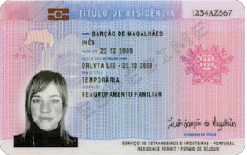







Residence Permit Card Example

VI. Our Office Services

When you choose to invest in real estate we are happy to find suitable properties and provide you with legal services which cover a wide variety of operations, such as purchase and sale of the property, distressed debt acquisition, commercial leasing, property management, licensing of various real estate projects in tourism, commercial, industrial and retail, structuring and joint ventures, loans arrangements, real estate investment fund formation, planning, construction and urban rehabilitation.
We also perform all the necessary due diligence during and following the purchasing process, assisting in negotiations with the seller, contracts drafting and providing assistance in completing the final deed, during and after the acquisition of the property, also advising on the management and maintenance of the assets.

What do we do:

- Assistance during the process of negotiations and preparing a safe Promissory Sale and Purchase Agreement;

- Analysis of all documentation - mainly at the Land Registry, in the tax office and at the local municipal council;

- Obtaining a Portuguese Tax Number at the local tax office;

- Representation for tax purposes;

- Opening a bank account;

- Drafting of the Power-of-Attorney enabling us to execute all the necessary tasks without your presence;

- Acting on behalf of the owner in various utility companies-providers: electricity, gas, water, telephone, cable TV, etc.;

- Preparation and submission of the Residence Permit and follow-up on the process at the Portuguese Immigration and borders Authorities (“SEF”);

- Full assistance with renewals of the Residence Permits;

- Applications for the Permanent Residence Permits and Citizenship;

The Management / Investment Consultancy service we provide:

- Tour of Real Estate Investment Options

- Advising on the management and maintenance of the assets;

- Rental agreements or other type of contracts;

- Issuance of the competent receipts regarding the rent;

- Serving as interface at the tax local authorities, paying the respective taxes;

- Serving as interface at an Insurance company, assisting the client in choosing a competitive packaged Liability Insurance Policy regarding the real estate;

- Representing the client during the building management meetings;

Government and Legal Fees - Investor Visa Residence permit

Description | Amount
Analysis of the investment and requirements | 527,60€
Analysis of all the documents regarding for each family member | 82,30€
Issuance the residence permit card | 5.274,40€ (for person)
Renewal of the residence permit card | 2.637,20€ (for person)
Legal fees | Please contact our office by email, skype or phone to receive an offer from our legal partners.

Schedule of Payments - Investor Visa – When Buying Real
Estate

1) 50% of PTGoldenVisa Consultancy Fee to initiate the process

2) Real Estate Deposit – Promissory Contract of Purchase and Sale (Expect to pay 10%-30% down payment) or Booking Fee/Reservation Deposit (10.000 Euro)

3) Payment of Transfer Tax and Stamp Tax After property registration

4) Payment of Public Notary Fees upon registering the Properties (750€ per property)

5) Payment of Real Estate Remaining Value – Final Public Deed

6) Payment of Government Fees upon Applying for RP – Analysis Fees

7) Payment of Government Fees – Issuance of Residence Permit Cards

8) Remaining 50% of the PTGoldenVisa Consultancy Fee payment against Residency Permit Cards delivery.

All payments must be done from your Personal Portuguese Bank account to each entity respectively and will have to be instructed by you directly to your personal account manager.

VII. First Steps to Start Investor Visa Application Procedure

If you are ready to start the process with us (PTGoldenVisa), please follow these steps:

- Plan a trip to Portugal and please send us in advance:
  - your passport scan;
  - a proof of Residence (last 3 months Utility Bill containing the Investor’s address and name). It must be translated into English (if not already in English);
  - a proof of Profession (Letter from your company signed and stamped mentioning your position and number of years in the company).
This initial trip is required to select the investment, obtain a Tax number and open a Bank account under Investor’s name. Only the investor is required on the first trip. Later on, investor together with all his dependents will have to travel to Portugal in order to to submit biometric data.

- Send us an email (info@PTGoldenVisa.com ) with a copy of your passport, advising on dates of your intended arrival in Portugal so that we can confirm availability and the number of persons along with their names that will be traveling with you. Please also advise which type of investment you would like to do, what is the budget and purpose. (For example, my budget is 500.000 Euro to buy one residential property well located for rental purpose. I do not intend to live there. Or a minimum investment of 350.000 Euro - old property to rent.)

- If you intend to complete your investment within 90 days , please prepare the Police Clearance Report for the Main Investor (Apostille or Stamped at Portuguese Embassy or Consulate) and everyone over 16 years old.
- Marriage Certificate (if applying with spouse), Birth Certificate of the Investor if applying with parents OR children birth certificates - if applying with your children. All documents must be legalized with an Apostille or Stamped at Portuguese Embassy or Consulate and translated into Portuguese Language.

When sending us an email, please make sure that you have selected one of the following options:

a) Our company selects the Real Estate options for you and introduces them to you during your visit so you could take the decision during your trip to Portugal.

b) You choose the Real Estate on your own and we will initiate the Residence Permit application procedure to ensure you will enjoy all of the benefits.

(Please note that it is mandatory that you choose one of these options before arriving to Portugal in order for us to make the plan accordingly)

- For Real Estate visits we recommend you to book 3 complete days in Lisbon and
3-4 days, should you wish to see Properties outside of Lisbon. We will make all the necessary arrangements for the visits.

Note: Our clients, who need an Invitation Letter in order to obtain a Schengen Visa, will be provided with such letter only after submitting 50% of our service fee and sending us a bank statement showing capacity for minimum investment required in the program.

- Apply for Schengen Tourist Visa in your closest Consulate in order to be able to enter Portugal.

- Inform us on your airport arrival time should you want us to pick you up at the airport or hotel you are going to stay in.
- Visit the Real Estate opportunities and check which one you are most comfortable with to start negotiating and proceed with acquisition.
- Make a Power-of-Attorney in the name of one of our lawyers for us to be able to manage all of the procedures without your physical presence.
- You would need to prepare and send us all documents required for Visa:
- Police Clearance Record for adults and children aged 16 and older,
- Birth Certificates for all dependents except spouse,
- Marriage Certificate when applying with spouse (if applicable)
- Proof of dependency (for example, studies) for all dependents aged 18 and older.

Please note that all the documents we require to be presented for the Residence Permit application can be sent to us anytime after your trip to Portugal. You do
not need to have them prepared before you make your first trip.


INVESTMENT OPTION: 280.000 Euro (1 Old Property Located in Low Density Area – Touristic Property) (Old properties with renovations more than 30 years old and located in areas with less than 100 habitants per km2)

 | Quantity | Value | Subtotal
Minimum Real Estate Investment: | 1 | €280 000,00 | €280 000,00
Transfer Tax: | 1 | €18 200,00 | €18 200,00
Stamp Tax 0.8% | 1 | €2 240,00 | €2 240,00
Notary Fees Deed and Registration: | 1 | €750,00 | €750,00
Notary Fees for Adults Power of Attorney: | 1 | €150,00 | €150,00
PT Golden Visa - Investor Fee: | 1 | €4 500,00 | €4 500,00
PT Golden Visa - Dependents: | 2 | €1 000,00 | €2 000,00
Government Analysis Fee (Investor): | 1 | €527,60 | €527,60
Government Analysis Fee (Dependent): | 2 | €82,30 | €164,60
Government Visa Fee: | 3 | €5 274,40 | €15 823,20
 |  | TOTAL | €324 407,20
RENEWALS
Government Visa Fee (per person): | 3 | €2 637,20 | €7 911,60
PT Golden Visa Renewal Fee: 750 Euro / Person: | 3 | €750,00 | €2 250,00
 |  | SUBTOTAL | €10 161,60
RENEW 3 TIMES |  | TOTAL | €30 484,80
Citizenship Application | 3 | €250,00 | €750,00
Considering Annual Tax Costs 0.3% of Property Value | 5 | €1 500,00 | €7 500,00
Considering a Management Fee of the Building | 5 | €700,00 | €3 500,00
 |  | SUBTOTAL | €11 750,00
FULL INVESTMENT |  | TOTAL | €366 590,20

INVESTMENT OPTION: 350.000 Euro (Old properties more than 30 years old)

 | Quantity | Value | Subtotal
Minimum Real Estate Investment: | 1 | €350 000,00 | €350 000,00
Transfer Tax: | 1 | €16 964,75 | €16 964,75
Stamp Tax 0.8% | 1 | €2 800,00 | €2 800,00
Notary Fees Deed and Registration: | 1 | €750,00 | €750,00
Notary Fees for Adults Power of Attorney: | 1 | €150,00 | €150,00
PT Golden Visa - Investor Fee: | 1 | €4 500,00 | €4 500,00
PT Golden Visa - Dependents | 2 | €1 000,00 | €2 000,00
Government Analysis Fee (Investor): | 1 | €527,60 | €527,60
Government Analysis Fee (Dependent): | 2 | €82,30 | €164,60
Government Visa Fee: | 3 | €5 274,40 | €15 823,20
 |  | TOTAL | €393 680,15
RENEWALS
Government Visa Fee (per person): | 3 | €2 637,20 | €7 911,60
PT Golden Visa Renewal Fee: 750 Euro / Person: | 3 | €750,00 | €2 250,00
 |  | SUBTOTAL | €10 161,60
RENEW 3 TIMES |  | TOTAL | €30 484,80
Citizenship Application | 3 | €250,00 | €750,00
Considering Annual Tax Costs 0.3% of Property Value | 5 | €1 500,00 | €7 500,00
Considering a Management Fee of the Building | 5 | €700,00 | €3 500,00
 |  | SUBTOTAL | €11 750,00
FULL INVESTMENT |  | TOTAL | €435 914,95

INVESTMENT OPTION: 500.000 Euro (free selection)

 | Quantity | Value | Subtotal
Minimum Real Estate Investment: | 1 | €500 000,00 | €500 000,00
Transfer Tax: | 1 | €28 964,75 | €28 964,75
Stamp Tax 0.8% | 1 | €4 000,00 | €4 000,00
Notary Fees Deed and Registration: | 1 | €750,00 | €750,00
Notary Fees for Adults Power of Attorney: | 1 | €150,00 | €150,00
PT Golden Visa - Investor Fee: | 1 | €4 500,00 | €4 500,00
PT Golden Visa - Dependents | 2 | €1 000,00 | €2 000,00
Government Analysis Fee (Investor): | 1 | €527,60 | €527,60
Government Analysis Fee (Dependent): | 2 | €82,30 | €164,60
Government Visa Fee: | 3 | €5 274,40 | €15 823,20
 |  | TOTAL | €556 880,15
RENEWALS
Government Visa Fee (per person): | 3 | €2 637,20 | €7 911,60
PT Golden Visa Renewal Fee: 750 Euro / Person: | 3 | €750,00 | €2 250,00
 |  | SUBTOTAL | €10 161,60
RENEW 3 TIMES |  | TOTAL | €30 484,80
Citizenship Application | 3 | €250,00 | €750,00
Considering Annual Tax Costs 0.3% of Property Value | 5 | €1 500,00 | €7 500,00
Considering a Management Fee of the Building | 5 | €700,00 | €3 500,00
 |  | SUBTOTAL | €11 750,00
FULL INVESTMENT |  | TOTAL | €599 114,95

INVESTMENT OPTION: 350.000 Euro (Investment Fund)

START THE PROGRAM
 | Quantity | Value | Subtotal
Minimum INVESTMENT FUNDS Investment: | 1 | €350 000,00 | €350 000,00
Notary Fees for 1 Adults Power of Attorney: | 1 | €150,00 | €150,00
PT Golden Visa - Investor Fee: | 1 | €4.500,00 | €4.500,00
PT Golden Visa - Dependents | 2 | €1 000,00 | €2 000,00
Government Analysis Fee (Investor): | 1 | €527,60 | €527,60
Government Analysis Fee (Dependent): | 2 | €82,30 | €164,60
Government Visa Fee: | 3 | €5 274,40 | €15.823,20
 |  | TOTAL | €373.165,40
RENEWALS
Government Visa Fee (per person): | 3 | €2 637,20 | €7.911,60
PT Golden Visa Renewal Fee: 750 Euro / Person: | 3 | €750,00 | €2 250,00
 |  | SUBTOTAL | €10 161,60
RENEW 3 TIMES |  | TOTAL | €30 484,80
Link to the society (optional) | 5 | €800,00 | €4.000,00
Citizenship Application | 3 | €250,00 | €750,00
 |  | SUBTOTAL | €4.750,00
FULL INVESTMENT |  | TOTAL | €408.400,20

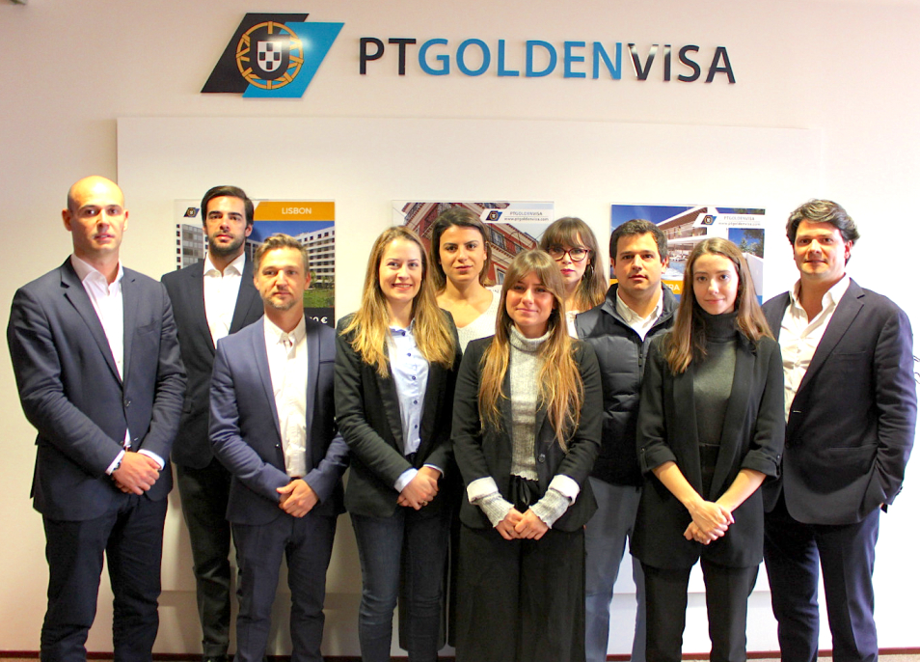

PTGoldenVisa
Contact: Sara Andrade
Tel: + 351 962 284 098
Email: info@ptgoldenvisa.com

www.ptgoldenvisa.com

Skype: PTgoldenvisa

Whatsapp: + 351 962 284 098

Viber: + 351 962 284 098

Wechat: + 351 962 284 09
Real Estate Consultant License AMI: 12717 | APEMIP Member License: 538
Please follow our updates and blog at:
Facebook: www.facebook.com/ptgoldenvisa | Google + : plus.google.com/+ptgoldenvisa

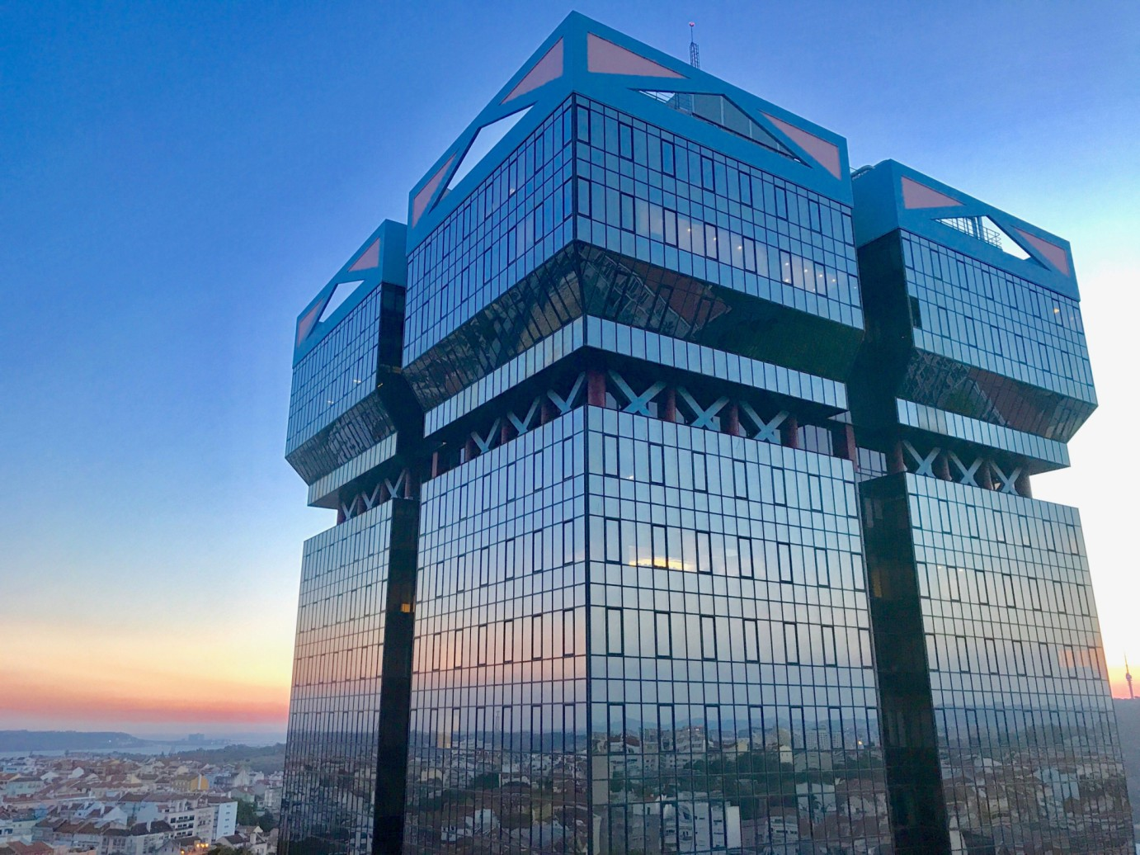
Main Office:

Avenida Eng.º Duarte Pacheco,
Edifício Amoreiras, Tower 2
Floor 9, Room 10
1070-103 Lisbon – Portugal

Dubai Office:

Level 14, Boulevard Plaza,
Tower One, Sheikh Mohammed
Bin Rashid Boulevard, Downtown Dubai,
United Arab Emirates,
PO BOX 5000075 UAE

